Come celebrate with us

Holy Family’s 150th Anniversary
Kick-off Event
Wine Tasting
March 19, 2022 7 to 10 pm
Costello Community Center
Hosted by Vino Veritas Cellars
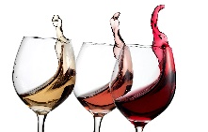
Entertainment by Jeff Varga
This Photo by Unknown Author is licensed under CC BY-NC-ND
Tickets $37.00 per person
Includes 4 - 2 oz. pours complimented with
meat, fruits, cheese, chocolates & crackers
Souvenir wine glass
Photo booth
Side boards
Late evening snack of pizza, sandwiches and coffee

Wine available for purchase by glass or bottle
Beer available for minimal cost

HELP US BUILD THE NEXT 150 YEARS OF HOLY FAMILY PARISH COMMUNITY

You may purchase tickets thru your student. Include your check in attached envelope and return to their teacher. Tickets will be returned to you in the same envelope. We hope to see you there as Holy Family begins their 150th Celebration!

(for more information, please contact Kay Gonet at 440-826-0226 or kaygonet@aol.com)

